PROJECT PROPOSAL
Guest Access System
Offline-First QR-Based Gate Validation for University Convocations
Prepared: March 2026
Version 1.0 | Internal

Document Type | Project Proposal
System | Guest Access System (GAS)
Target Deployment | Sierra Leone University Convocations
Capacity | Up to 3,000 attendees per event
Architecture | Offline-first PWA with Service Worker sync
Classification | Internal / Engineering

1. Executive Summary
University convocation ceremonies in Sierra Leone currently rely on paper-based guest pass systems that are vulnerable to duplication, lack real-time capacity tracking, and provide no post-event audit trail. With venues hosting up to 3,000 attendees across multiple entry gates, the manual approach creates security blind spots and operational bottlenecks.
This proposal presents the Guest Access System (GAS), a purpose-built digital solution that replaces paper passes with QR-coded digital passes, validated in real-time at entry gates using a Progressive Web Application (PWA) running on officers' personal smartphones.

Core Innovation: Offline-First Architecture
Unlike conventional QR validation systems that require constant internet connectivity, GAS is designed to operate fully offline during the event. Gate devices pre-load a complete pass manifest before the ceremony begins. All validation happens locally against the device's IndexedDB store. A Service Worker manages background synchronization through a three-tier fallback chain (LAN mesh, mobile internet, fully offline), ensuring that phone calls, app switches, or connectivity loss never interrupt gate operations.

Key capabilities:
- Digital pass issuance with QR codes for graduates and their guests
- Real-time gate validation that works with zero internet connectivity
- Cross-gate duplicate detection via local network mesh or opportunistic internet sync
- Vehicle parking quota enforcement with database-level race condition prevention
- Complete audit trail: who approved what, when passes were scanned, which gate, which officer
- Post-event reconciliation and reporting

2. Problem Statement

2.1 Current Challenges
The existing paper-based pass system presents several operational and security risks that scale poorly with growing class sizes:

Challenge | Impact | Severity
Paper passes are easily duplicated | Unauthorized entry; venue overcrowding beyond safe capacity | Critical
No real-time admission count | Event organizers cannot track how many guests have entered vs. capacity | High
Vehicle parking overflows | Cars turned away at gates; traffic congestion on campus roads | High
No post-event audit trail | Impossible to investigate security incidents or verify attendance records | Medium
Manual gate coordination | Faculty-gate assignments communicated verbally; errors are common | Medium
Internet dependency in similar digital systems | Any cloud-based QR system fails when connectivity drops mid-ceremony | Critical

2.2 Deployment Context
The target deployment environment is Sierra Leone, where infrastructure constraints shape every design decision:
- Internet connectivity is intermittent and unreliable, particularly during large gatherings that strain local cell towers
- Power outages can occur without warning, potentially disabling network equipment mid-event
- Gate officers use personal smartphones (Android-dominant) rather than dedicated hardware
- Technical literacy varies among staff; the system must be operable with minimal training

Design Constraint
Any system that requires constant internet connectivity to validate a pass is unsuitable for this environment. The architecture must treat connectivity as a bonus, not a requirement.

3. Proposed Solution

3.1 System Overview
GAS operates in two distinct modes, separated by time:

Mode | When | Connectivity | What Happens
Online (Pre-event) | Days before ceremony | Required | Graduate registration, pass requests, admin approvals, QR generation, manifest preparation
Offline-first (Event day) | During ceremony | Optional | Gate validation runs locally on each device. Sync is opportunistic, not required.

This separation is the fundamental architectural decision. All connectivity-dependent operations (registration, approvals, QR generation) happen well before the event, when timing is flexible. The time-critical operation (gate scanning) depends on nothing but the device in the officer's hand.

3.2 Technology Stack
Component | Technology | Rationale
Backend API | Django REST Framework + PostgreSQL | Mature, well-documented, strong ORM for complex queries and transactions
Gate PWA | Preact + IndexedDB + Service Worker | Lightweight, offline-capable, runs on any modern smartphone browser
Background sync | Service Worker with adaptive intervals | Survives app backgrounding (phone calls, WhatsApp), independent of UI lifecycle
LAN mesh | WebSocket over local WiFi router | Sub-second cross-gate sync without internet dependency; $15 hardware cost
QR generation | Server-side; 17-char base62 codes | 101 bits of entropy; simple URL encoding; no cryptographic complexity at the gate

3.3 How Gate Validation Works
When a gate officer scans a QR code during the event, the following happens entirely on their device:
- Camera reads QR code, PWA extracts the 17-character base62 pass code from the URL
- IndexedDB lookup by pass code (sub-50ms, no network call)
- Validation checks run locally: pass exists, not revoked, not expired, not already scanned, correct gate type
- Result displays immediately: ADMITTED (green), or a specific denial reason (red/yellow)
- Scan result is written to the local scan log and queued for background sync
The entire flow completes in under 50 milliseconds. The officer sees the result before they can lower their phone.

4. Offline-First Architecture
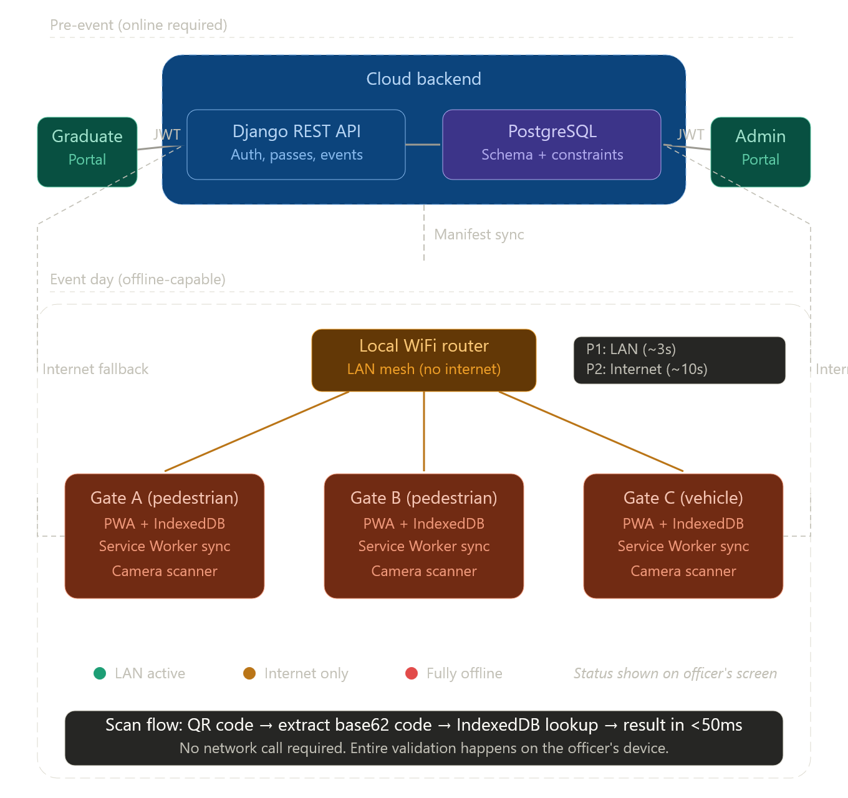
The offline-first design is the defining feature of this system. This section explains the four operational phases and the sync resilience strategy in detail.

4.1 Phase 1: Pre-Event Manifest Sync
Before the event starts, each gate device downloads a complete pass manifest from the server. This is the only moment internet is strictly required, and the timing is controlled by the event operator (typically the morning of or night before the ceremony).
The manifest includes:
- All approved, non-revoked passes for the event (approximately 3,000 records)
- Event time window (start and end timestamps)
- Gate ID and type assignment for this specific device
- A version number for incremental sync

Critical design decision: Every gate receives ALL passes, not just its assigned faculty's passes. This means that if crowd flow forces a gate reassignment mid-event, the device still validates any pass without needing to re-sync. The storage cost is trivial: 3,000 JSON records occupy roughly 500KB in IndexedDB.

4.2 Phase 2: Offline Gate Validation
During the event, every scan is validated against the local IndexedDB store. No network call is made. The validation engine checks six conditions in sequence: pass existence, revocation status, gate type match, time window, local duplicate, and cross-gate duplicate (from synced data). Any failure returns an immediate, specific result code to the officer.

4.3 Phase 3: Background Sync via Service Worker
A Service Worker runs independently of the PWA's foreground UI. This is essential because gate officers use personal phones; incoming calls, WhatsApp messages, or accidental app switches push the PWA to the background. The Service Worker continues syncing regardless.

The sync loop follows a three-tier priority chain:

Priority | Channel | When Active | Cross-Gate Detection Delay
1 (preferred) | LAN mesh via local WiFi router | Router powered and reachable | ~3 seconds
2 (fallback) | Internet to cloud server | Router down, mobile data available | ~10 seconds
3 (degraded) | Fully offline | Both LAN and internet unreachable | Caught post-event

Transitions between tiers are automatic and invisible to the gate officer. A small colour-coded indicator (green/yellow/red) on the scan screen shows the current sync status for supervisory awareness, but requires no action from the officer.

4.4 Adaptive Sync Intervals
The Service Worker uses an adaptive interval strategy to balance responsiveness against battery and data consumption:
- LAN healthy: check every 3 seconds (WebSocket pings are cheap on a local network)
- LAN failed, internet active: check every 10 seconds (mobile data is metered)
- Both failing: exponential backoff from 10 seconds to a cap of 60 seconds (conserve battery)
- Any connectivity restored: immediately reset to the appropriate fast interval

4.5 Phase 4: Post-Event Reconciliation
After the ceremony concludes, all devices sync their complete scan logs to the server. A reconciliation job groups scans by pass code, identifies any cross-gate duplicates that occurred during connectivity gaps, and generates a report for the event operator.
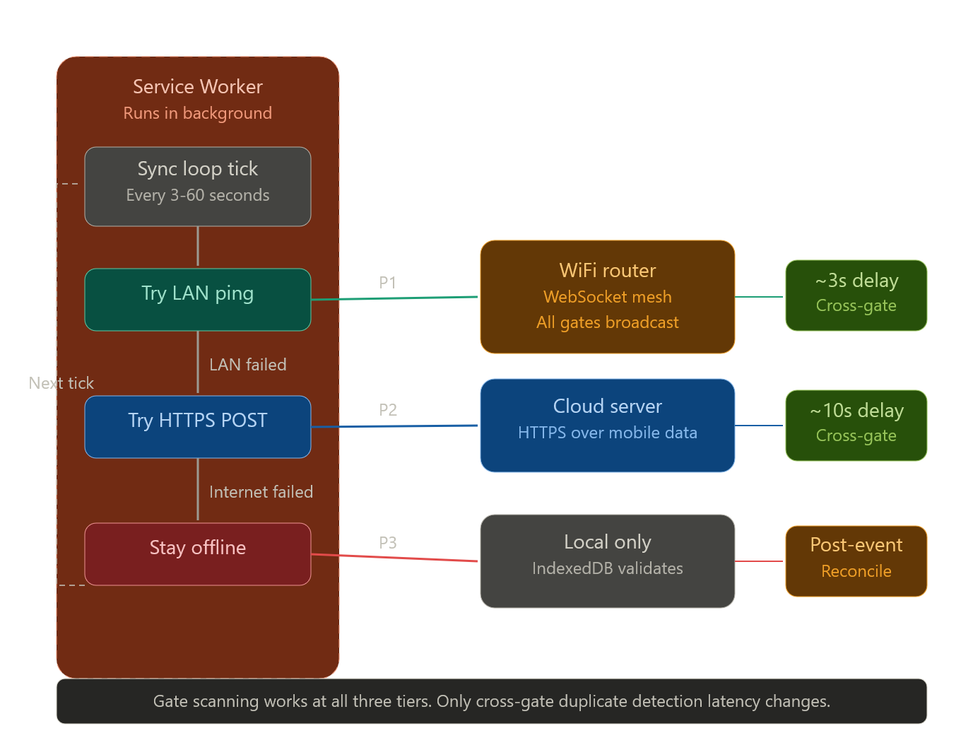

5. Security Model

5.1 QR Code Security
The QR code encodes a simple URL containing a 17-character base62 code. This deliberately avoids cryptographic complexity (HMAC signatures, JWTs embedded in QR images) in favour of a model where the security comes from code entropy and single-use enforcement:
- Entropy: 17 base62 characters provide approximately 101 bits of entropy. Brute-forcing a valid code would require on average 3.1 x 10^30 attempts.
- Single-use enforcement: Once a code is scanned, the local IndexedDB marks it as consumed. A second scan at the same gate is rejected instantly.
- Cross-gate protection: Scans propagate to other gates via the sync mesh. A duplicated QR used at a different gate is detected within 3-10 seconds when connectivity exists.

5.2 Graduate Authentication
Graduates authenticate to the portal using their Student ID and Receipt Number. The receipt number is bcrypt-hashed before storage and never appears in logs or API responses. Failed login attempts trigger a lockout (5 attempts, 15-minute cooldown) to prevent credential stuffing.

5.3 Role-Based Access Control
Role | Access Level
SUPER_ADMIN | Full system access: manage events, users, quotas, approve/revoke passes, all reports
EVENT_OPERATOR | Event lifecycle management, gate assignments, reporting. Cannot approve vehicle passes or modify quotas.
GATE_OFFICER | Scan passes at assigned gate. View own scan history only.
AUDITOR | Read-only access across the entire system for compliance and review purposes.

5.4 Audit Trail
Every administrative action (pass approval, revocation, quota change, event state transition) is recorded in an immutable audit log with the acting user, timestamp, previous value, and new value. This log cannot be modified or deleted by any role, including SUPER_ADMIN.

6. Event Lifecycle and Parking Quota

6.1 Event State Machine
Each event progresses through a strict sequence of states. Transitions are enforced at the database level; skipping states is not possible.

State | What Is Allowed | Transition
DRAFT | Create and edit event details, set quotas, and assign gates to faculties | REGISTRATION_OPEN
REGISTRATION_OPEN | Graduates request passes; admins approve or reject | REGISTRATION_CLOSED
REGISTRATION_CLOSED | No new requests accepted; admin can still revoke passes | LIVE
LIVE | Gate validation active; sync running; pass revocation still possible | CLOSED
CLOSED | Post-event reconciliation; reporting; data retention timer starts | (terminal state)

6.2 Vehicle Parking Quota
Vehicle passes are subject to a per-event quota. The approval process uses a PostgreSQL row-level lock (SELECT ... FOR UPDATE inside a transaction) to prevent race conditions when multiple administrators approve passes concurrently. If two admins attempt to approve the last available slot simultaneously, exactly one succeeds; the other receives a QUOTA_EXCEEDED response. No application-level locking or external coordination is required.

6.3 Pass Revocation
Any approved pass can be revoked before or during the event. Revocation is immediate on the server. On gate devices, the revocation propagates on the next sync cycle (3-10 seconds with connectivity). A revoked pass returns a clear REVOKED result code when scanned, regardless of whether it was previously admitted.

7. Implementation Roadmap

7.1 Phased Delivery
Phase | Duration | Deliverables
Phase 1: Core Backend | 3 weeks | PostgreSQL schema, Django REST API (events, graduates, passes, auth), admin panel, CSV import
Phase 2: Gate PWA | 2 weeks | Preact PWA with camera scanner, IndexedDB manifest loader, local validation engine, result display UI
Phase 3: Service Worker Sync | 2 weeks | Three-tier sync loop, adaptive intervals, remote_scans store, sync status indicator, LAN WebSocket mesh
Phase 4: QR and Email | 1 week | QR code generation, email delivery with credentials and pass QR, email delivery logging
Phase 5: Reconciliation and Reporting | 1 week | Post-event reconciliation job, cross-gate duplicate detection, event summary reports, data retention job
Phase 6: Testing and Pilot | 2 weeks | End-to-end testing with simulated offline scenarios, pilot run at a single event, officer training

Total estimated timeline: 11 weeks from kickoff to pilot deployment.

7.2 Infrastructure Requirements
Component | Specification | Estimated Cost
Cloud server (backend) | Railway or similar PaaS; 1 vCPU, 1GB RAM, PostgreSQL addon | $5-15/month
Domain and SSL | Custom domain with Let's Encrypt SSL for gate URL | ~$12/year
Local WiFi router (per venue) | Any basic WiFi router for LAN mesh; no internet connection needed | ~$15 one-time per venue
Gate devices | Officers' personal Android smartphones (no dedicated hardware) | $0 (BYOD)
Email service | Transactional email provider (e.g. Brevo free tier) for credential delivery | $0 (free tier sufficient)

Total Infrastructure Cost
Approximately $20-30/month in recurring costs, plus a one-time $15 router purchase per venue. The system requires no dedicated hardware for gate officers.

8. Risks and Mitigations
Risk | Likelihood | Impact | Mitigation
Total connectivity loss during event (LAN + internet) | Medium | Low | Gate devices operate fully offline. Only cross-gate duplicate detection is delayed.
Gate device battery dies mid-event | Low | Medium | Officers carry portable chargers. Scan logs are persisted in IndexedDB; device resumes where it left off.
Duplicated QR used at two different gates during connectivity gap | Very Low | Low | Post-event reconciliation catches all cross-gate duplicates. Operational risk is minimal for a convocation.
Service Worker terminated by browser | Low | Low | Keep-alive pings from foreground page. Periodic Background Sync API where supported.
Officer unfamiliar with smartphone scanning | Medium | Low | Training session before event. The PWA UI is single-purpose: point the camera and read the result.
Power outage disables WiFi router | Medium | Low | System auto-falls back to internet sync, then fully offline. No manual intervention.

9. Conclusion
The Guest Access System addresses a real and growing operational problem for university convocations in Sierra Leone. Its offline-first architecture is not an afterthought but the core design principle, built specifically for an environment where connectivity cannot be guaranteed.
By separating connectivity-dependent operations (registration, approvals) from time-critical operations (gate scanning), the system ensures that the moment that matters most, the gate officer scanning a pass as 3,000 guests arrive, never depends on infrastructure outside the officer's own device.
The technical approach is deliberately conservative: proven technologies (Django, PostgreSQL, Preact, IndexedDB, Service Workers), minimal external dependencies, and a preference for simple, enforceable rules over configurable complexity. Every design decision documented in the accompanying Software Requirements Specification (SRS v2.1) traces back to a concrete operational requirement or a known infrastructure constraint.

Recommended next step: Approve development kickoff for Phase 1 (Core Backend), targeting a pilot deployment at the next scheduled convocation ceremony.

End of Proposal

